[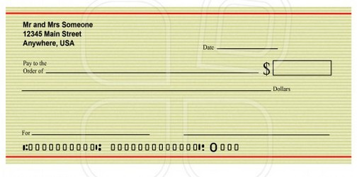](http://www.bank-check.org/wp-content/uploads/2011/01/Pic-Of-Blank-Check.jpg)

[](http://www.bank-check.org/wp-content/uploads/2011/01/Pic-Of-Blank-Check.jpg)